Activity 1: To-Do List API + UI

This is a modern take on the traditional To-Do list on paper, it focuses on simplicity and functionality. This helps you stay on top of your daily activities. You can quickly add new tasks, update them when plans change, mark items as complete with a simple checkbox, or remove them when they’re no longer needed. Designed with a clean and vibrant interface, it makes organizing your schedule both practical and visually engaging.

Members:
Andaya, Rhodel
Benito, Patrick Raymond P.
Cielo, Ivan Louis D.
De Leon, Justin Carl V.
Dela Cruz, Althea
Dela Cruz, Filbert B.

Visual Overview

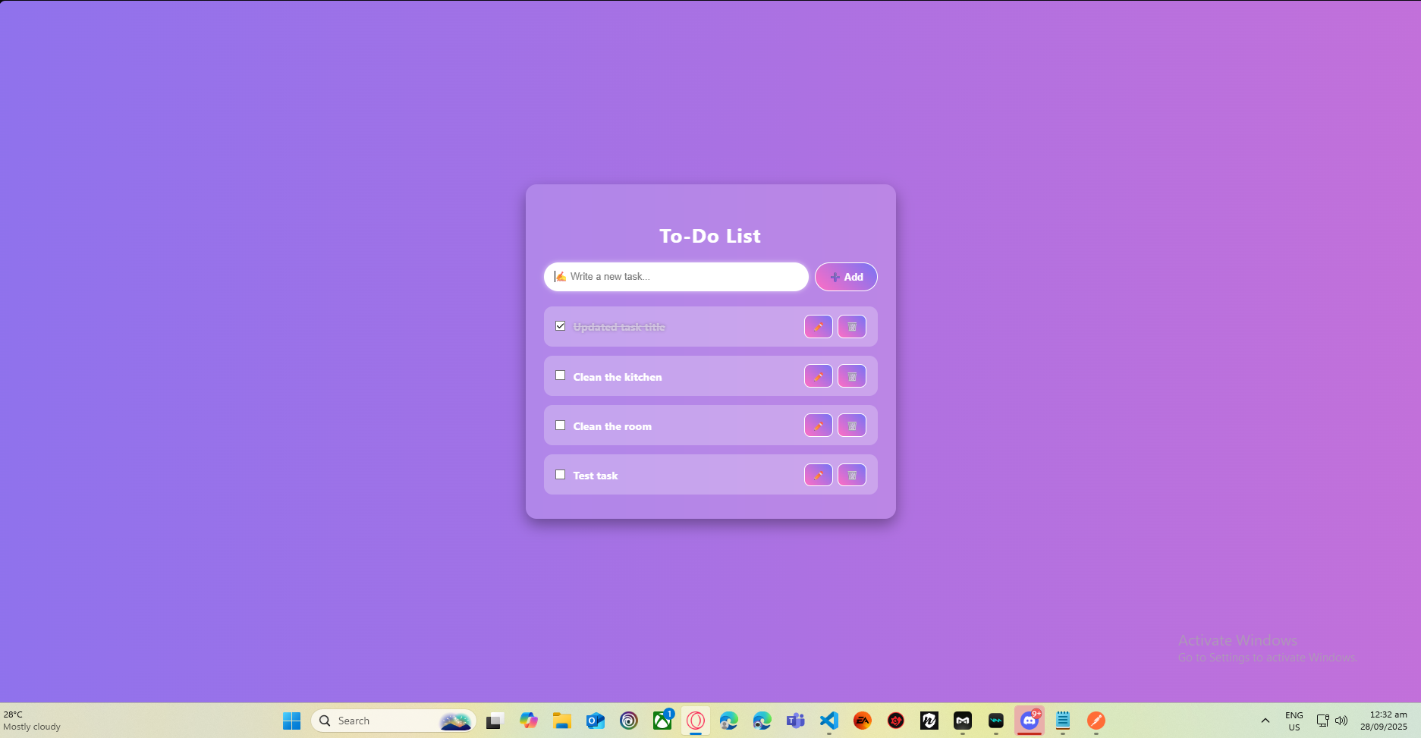

Steps in showing functionality:

Add Task Feature
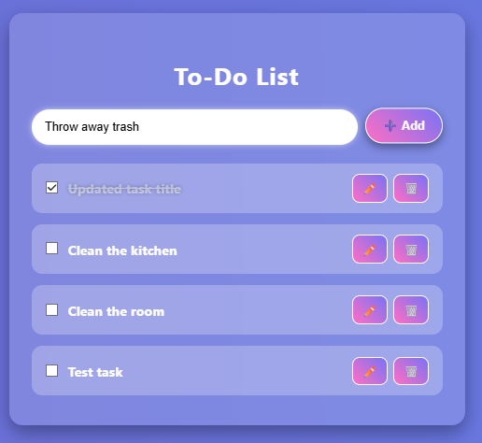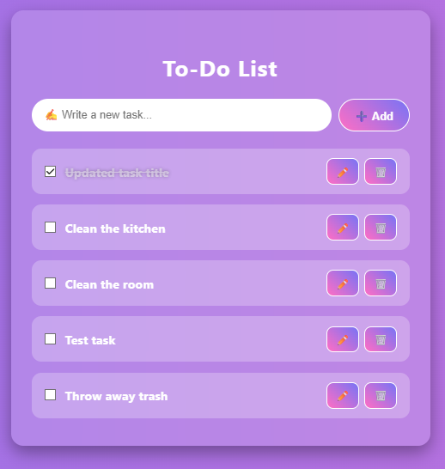

Users can add new tasks by typing the task name in the input field at the top of the to-do list and clicking the "Add" button. Once added, the task appears in the list below with options to mark as complete, edit, or delete.
Task Completion Feature
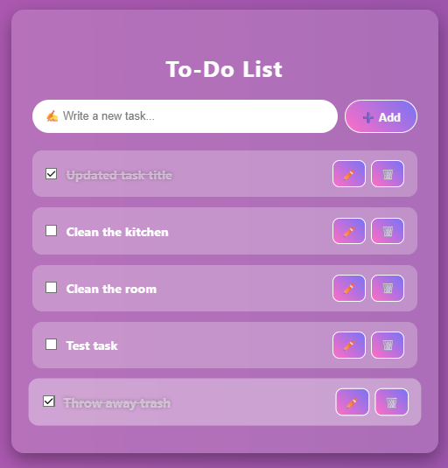

Users can mark tasks as complete by clicking the checkbox next to each task item. When checked, the task is visually indicated as finished (shown with a checkmark and strikethrough text), helping users track their progress through the to-do list.

Task Editing Feature
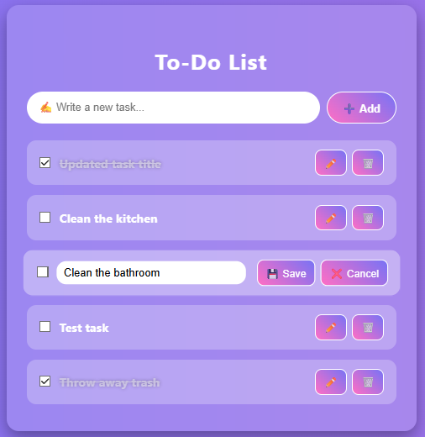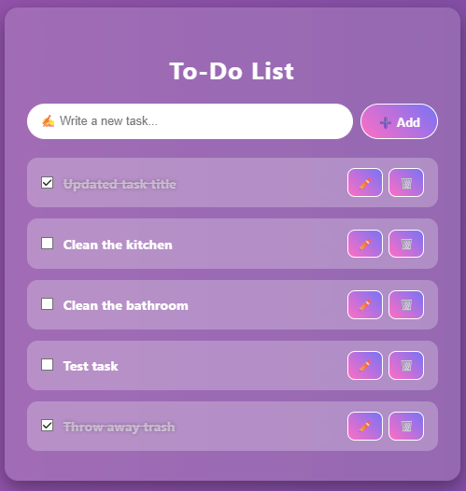

Users can edit existing tasks by clicking the edit button (pencil icon) on any task item. This opens an inline editor where the task text can be modified. Users can save the changes by clicking the "Save" button or cancel the edit by clicking "Cancel" to revert to the original text.

Task Deletion Feature
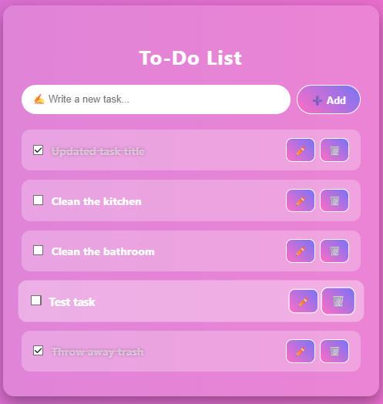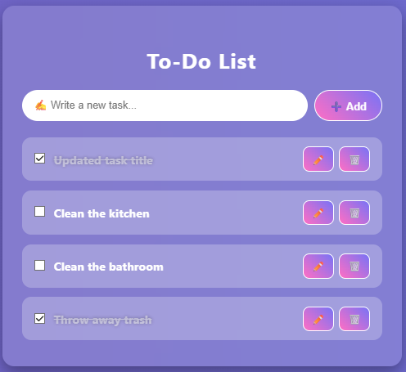

Users can remove tasks from their to-do list by clicking the delete button (trash icon) on any task item. Once clicked, the task is permanently removed from the list, allowing users to keep their task list clean and up-to-date.

API Connectivity Testing:

Adding a New Task
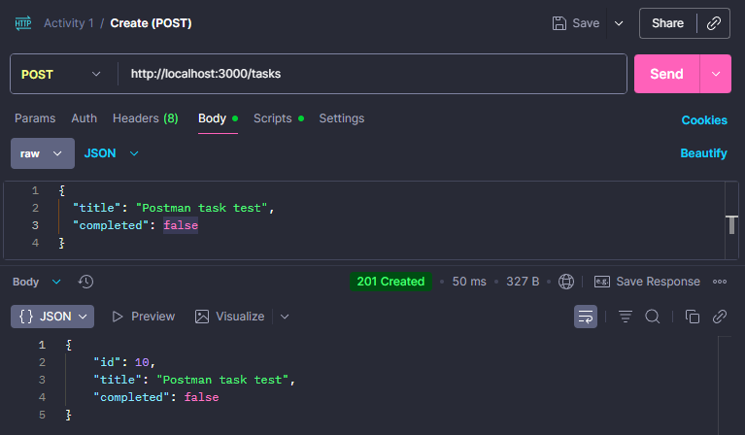

This test verifies the API's ability to create a new task by sending a POST request to the endpoint http://localhost:3000/tasks. The request body contains JSON data with task properties including "title" (e.g., "Postman task test") and "completed" status (set to false). A successful response returns a 201 Created status code with the newly created task object, including an auto-generated "id" field, confirming the task has been added to the database.

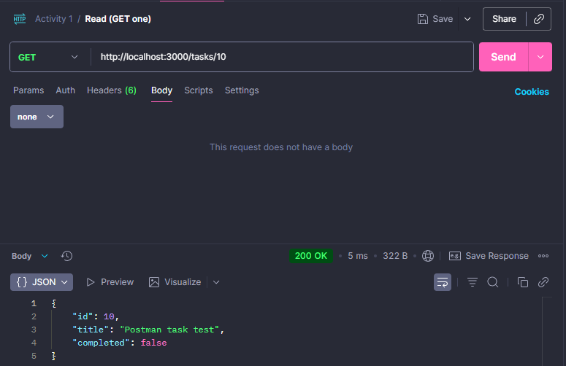
Retrieving Tasks

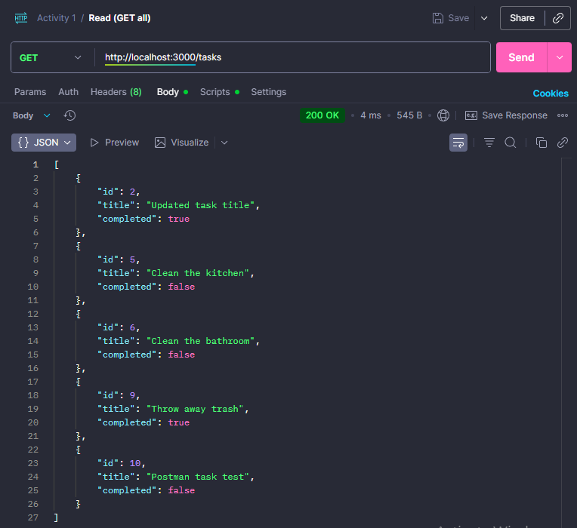

GET One Task
This test retrieves a specific task by sending a GET request to http://localhost:3000/tasks/10, where "10" is the task ID. A successful response returns a 200 OK status code with the task object containing its "id", "title" (e.g., "Postman task test"), and "completed" status.
GET All Tasks
This test retrieves all tasks by sending a GET request to http://localhost:3000/tasks. A successful response returns a 200 OK status code with an array of all task objects in the database. Each task includes its "id", "title" (such as "updated task title", "Clean the kitchen", "Clean the bathroom", "Throw away trash", "Postman task test"), and "completed" status, allowing users to view their complete task list.

Modifying a Task

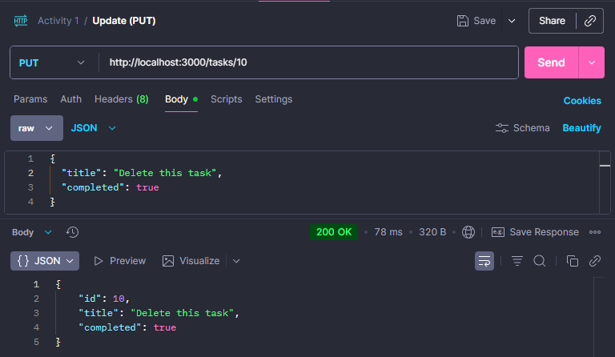

This test updates an existing task by sending a PUT request to http://localhost:3000/tasks/10, where "10" is the task ID. The request body contains JSON data with the updated task properties, including a new "title" (e.g., "Delete this task") and modified "completed" status (set to true). A successful response returns a 200 OK status code with the updated task object, confirming the changes have been saved to the database.

Removing a Task

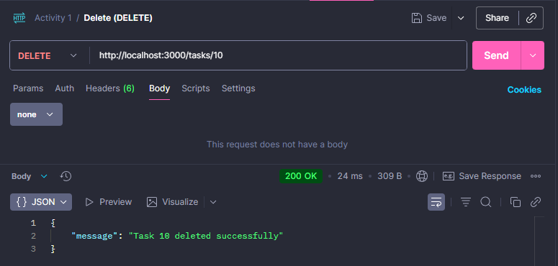

This test deletes a specific task by sending a DELETE request to http://localhost:3000/tasks/10, where "10" is the task ID. This request does not require a body. A successful response returns a 200 OK status code with a confirmation message (e.g., "Task 10 deleted successfully"), confirming the task has been permanently removed from the database.

—-------------------------------------------------------------------------------------------------------

Instructions to run the project:
1. Clone the repository
git clone https://github.com/chimken-adobo/Laboratory-Activities.git
cd Activity 1 Folder

2. Start the Back-End (NestJS API)
-Go into the backend folder
cd act1backend

-Install dependencies
npm install

-Start the NestJS server
npm run start

3. Start the Front-End (React App)
1. Open a new terminal and go into the React front-end folder
cd activity1

-Install dependencies
npm install

Start the React app
npm start

Note: After starting the Front-end it will ask this: Would you like to run the app on another port instead? » (Y/n)

Just press Y

⚠️IMPORTANT⚠️

IF THIS POPS UP WHEN INSTALLING "To address all issues (including breaking changes), run:
npm audit fix --force"

**DON'T DO IT**.

Now if you accidentally did it, you need to follow these steps to fix it.
**Inside Bash**

* 1. In your front-end folder (activity1):

rm -rf node_modules package-lock.json

* 2. Reinstall react-scripts manually, Since it’s missing or broken, install the exact version your project expects:

npm install react-scripts@5.0.1 --save

* 3. Reinstall everything else

npm install

* 4. Start the app again

npm start

